MATLAB Assignment 2

Submitted by Subhang Vempati
Question1:

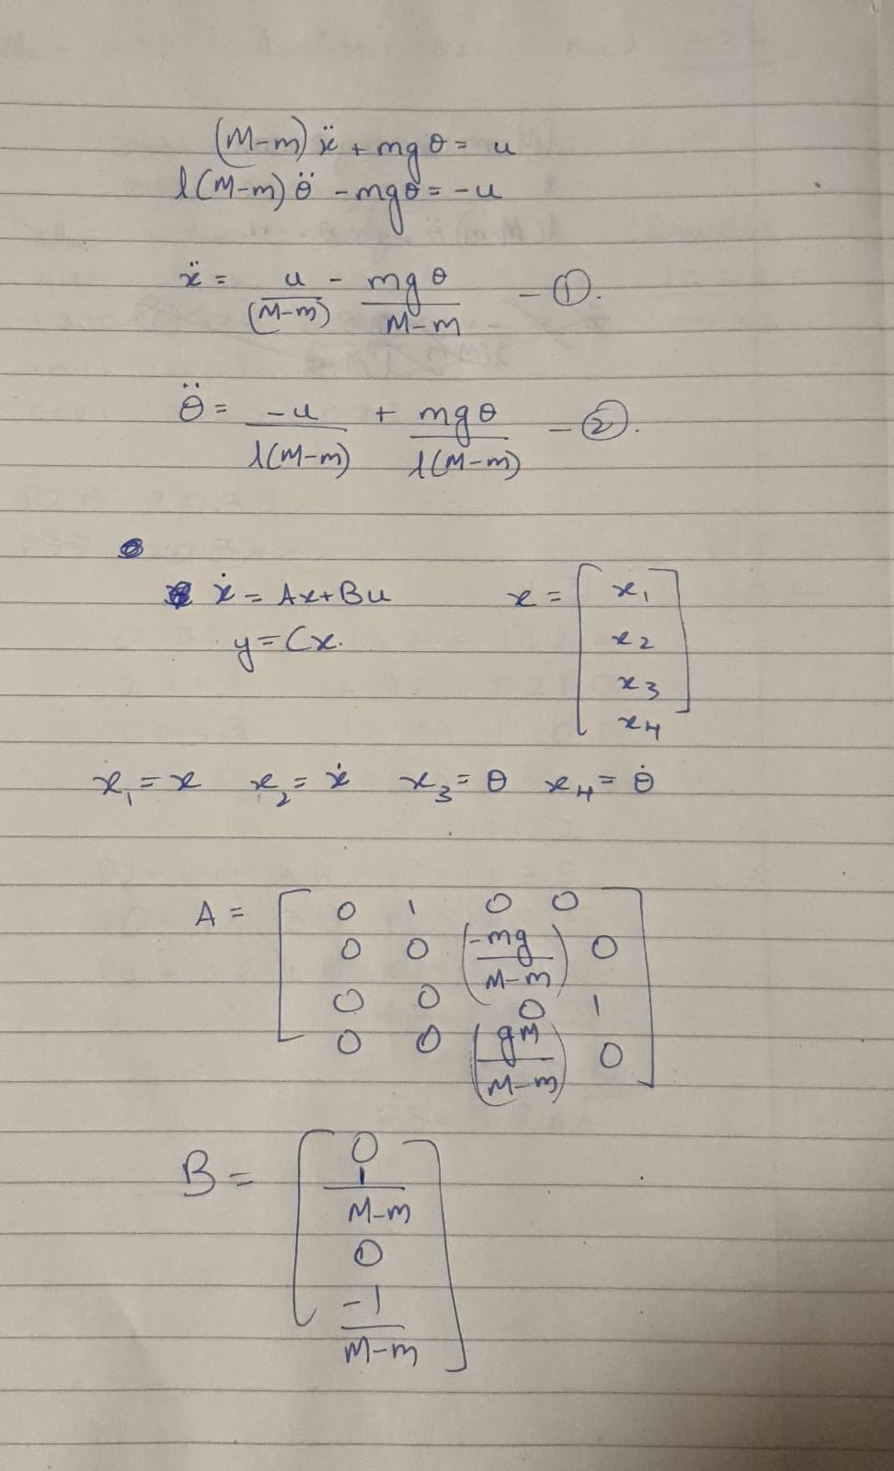
Problem a:

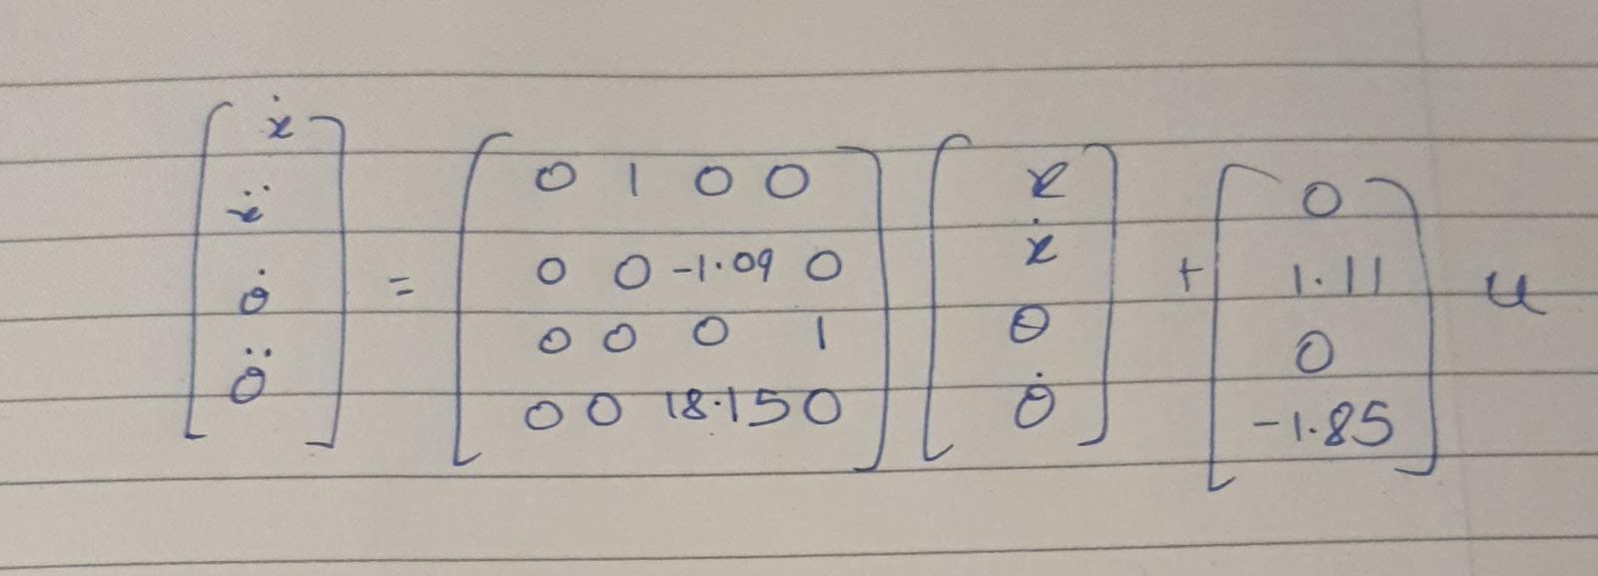

Problem b:
Here we are given the condition that only the angular position of the pendulum is measurable. Intuitively this means that we are trying to keep the pendulum upright just by controlling the angular position of the pendulum.
I tried both adding PID and PI controllers for this part. I used the Tuner tool in Control system Toolbox for tuning the parameters.
Initial conditions Cart position x=0, Cart Velocity x_dot=0,Angle theta=20 degrees, Angular acceleration theta_dot=0.The pendulum started tilted initially.
I was able to observe that with PID controller I was able to achieve what we wanted. Even with disturbance the pendulum came to upright position eventually. And states and the control signal eventually came to a stable state.
However, with PI controller I was not able to achieve this. When system started with a tilted pendulum, I observed that all states along with control signal where oscillating and following a diverging pattern.
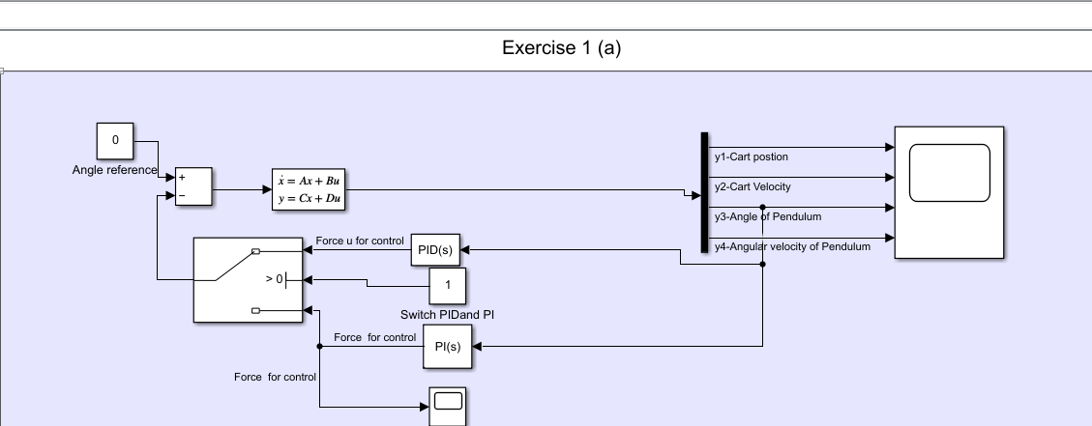

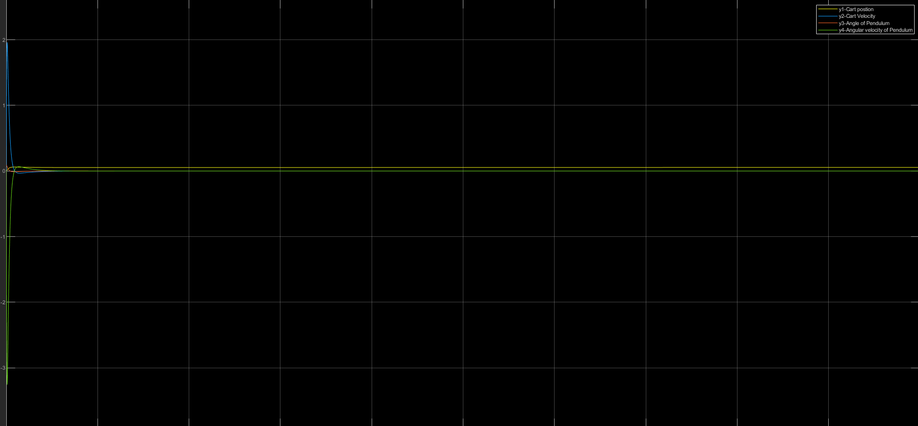

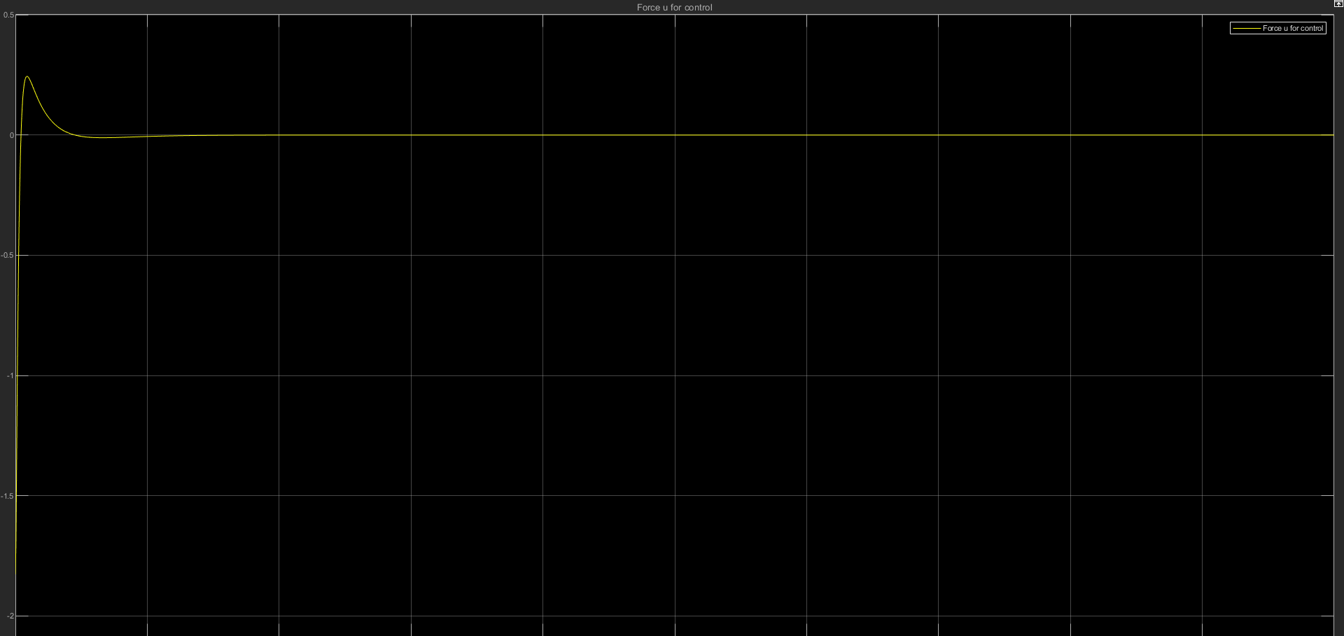

Problem c:
In this scenario, we have only angular velocity as the measurable state. I tried again to see if its possible to keep the pendulum upright by angular velocity this time with a PID controller.
I gave a unit step signal as reference signal and used the same initial conditions as before with a titled pendulum.
I was able to observe that when started with a disturbance, the pendulum did eventually come to a stable angle but it was not upright though.
And as for the cart, the velocity was increasing and cart kept on moving.
Once the pendulum reached a stable state, a constant control input was required to maintain it.

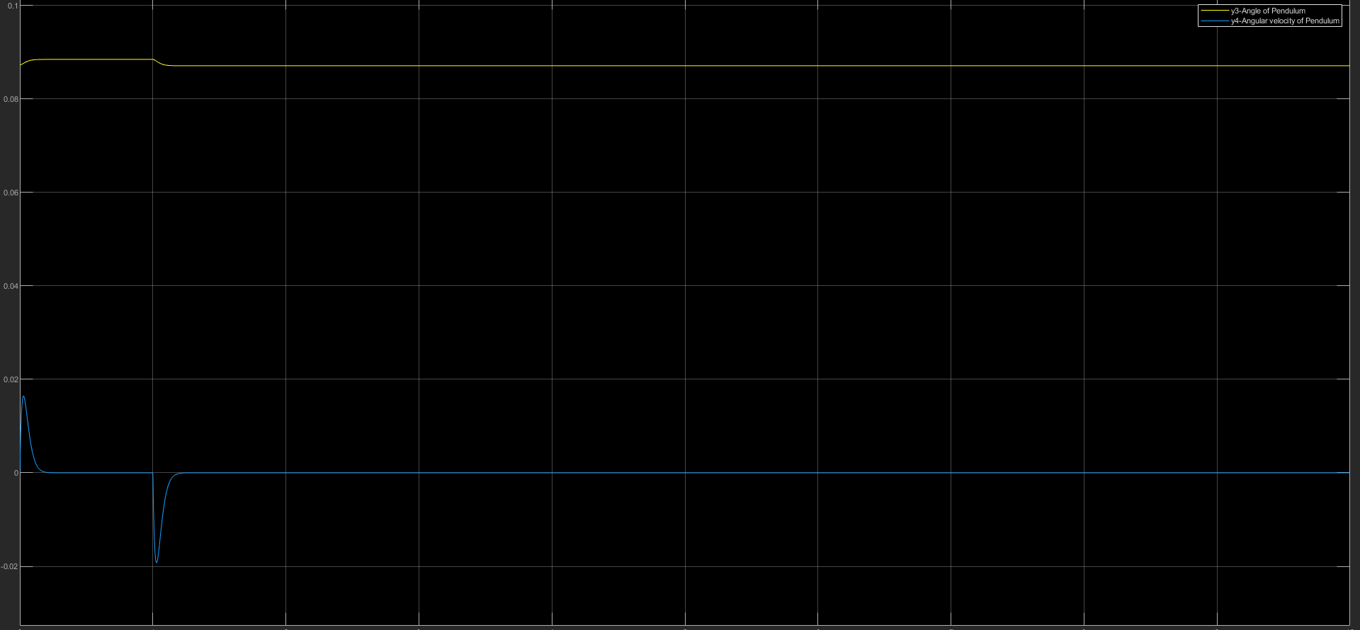
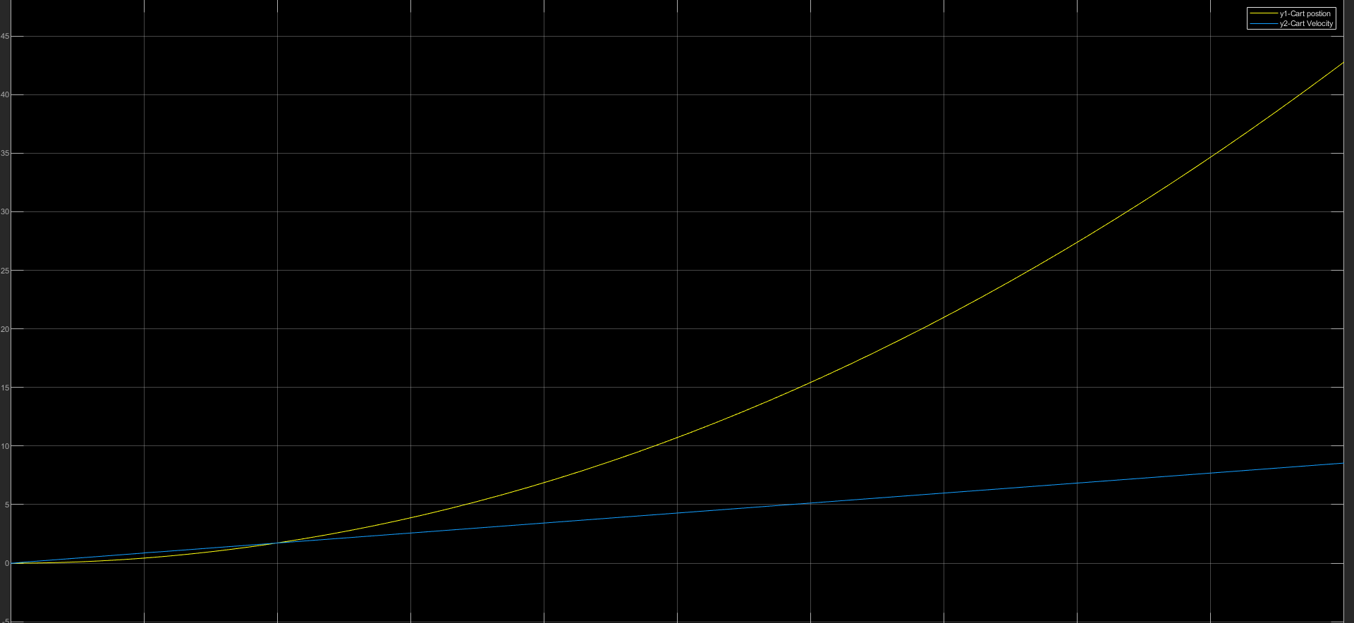
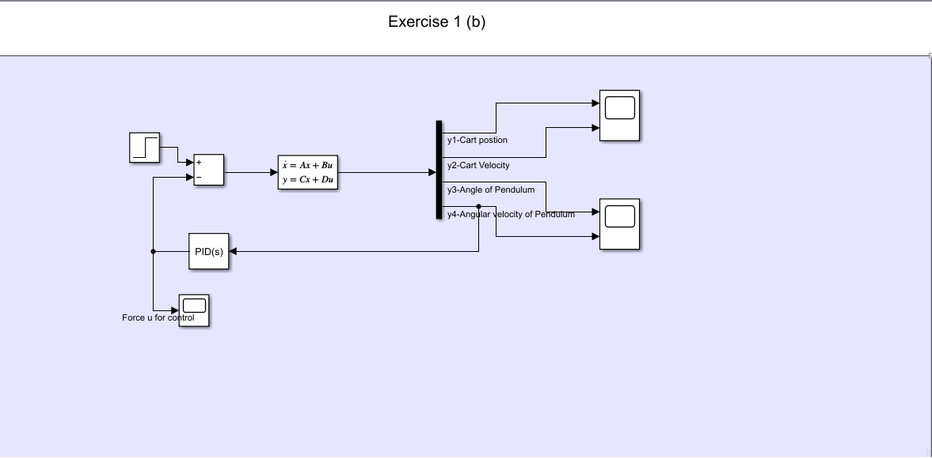
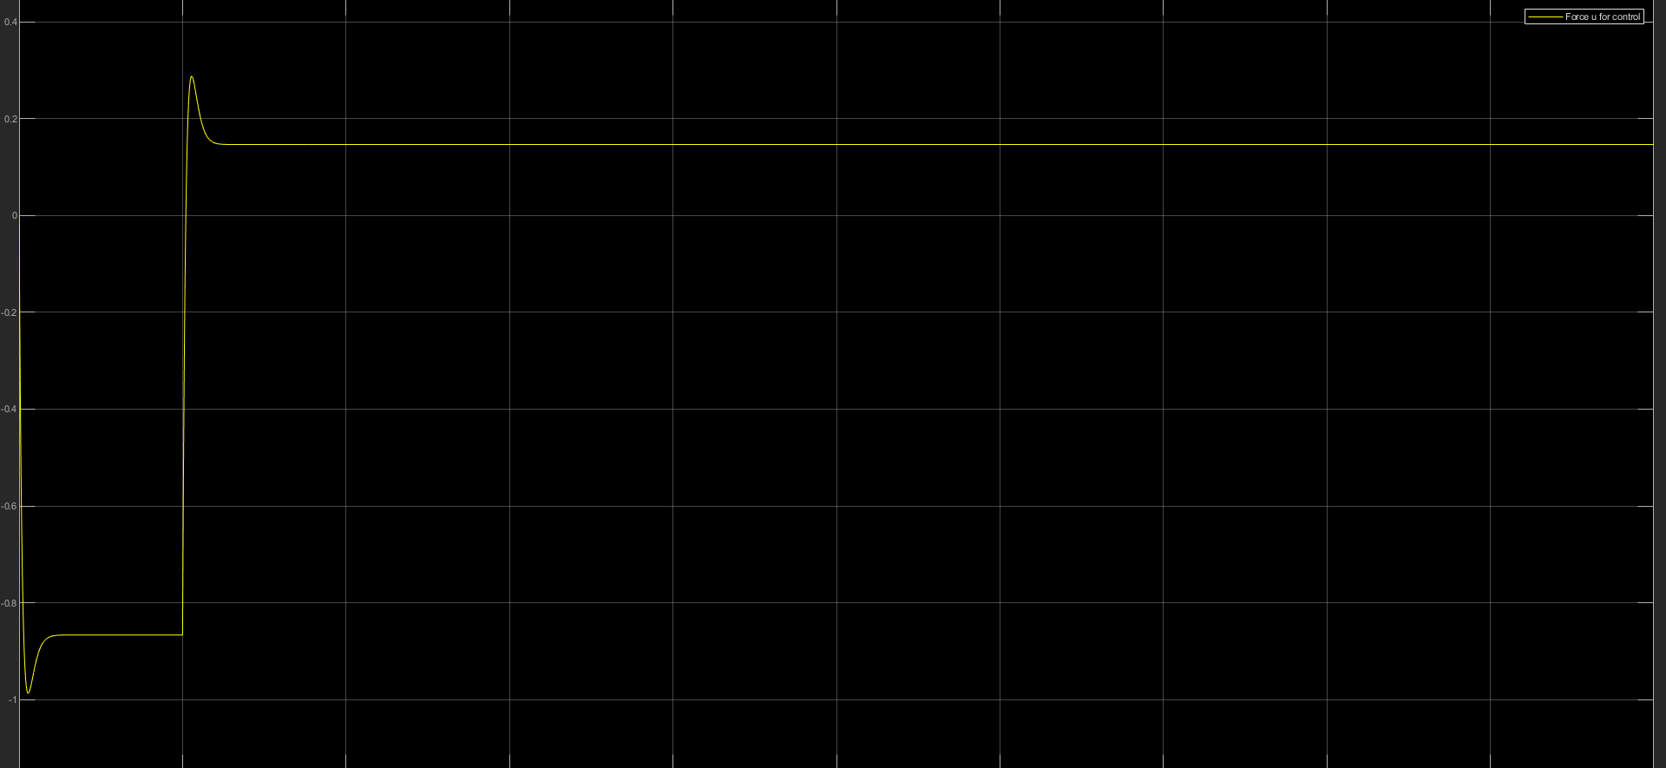

Problem d:
My observations shared for part b are already for the titled case. If you see the observations there we can see the cart has been displaced from origin to a different location until the system was stable, at which point it stopped and stayed there.

Exercise 2

Problem a.
Now we have all states measurable. A full space feedback controller is designed with pole placement.
Poles used=[-7,-7,-7,-7]
I reached this number by checking Eigen values of matrix and seeing the stable pole. I decided to start at this point but found the response to satisfactory and practically realizable.
Design
des_pole=[-7;-7;-7;-7];
K=acker(A,B,des_pole);
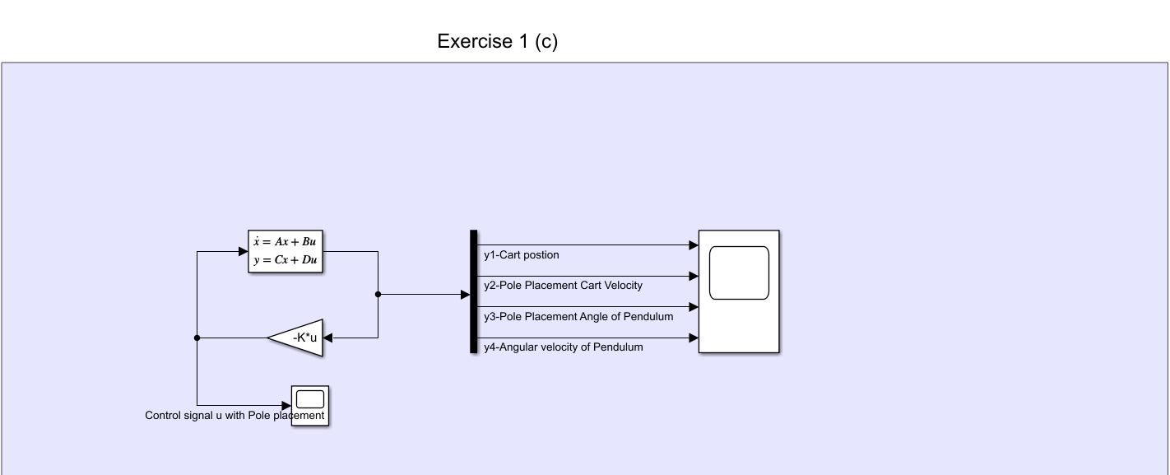

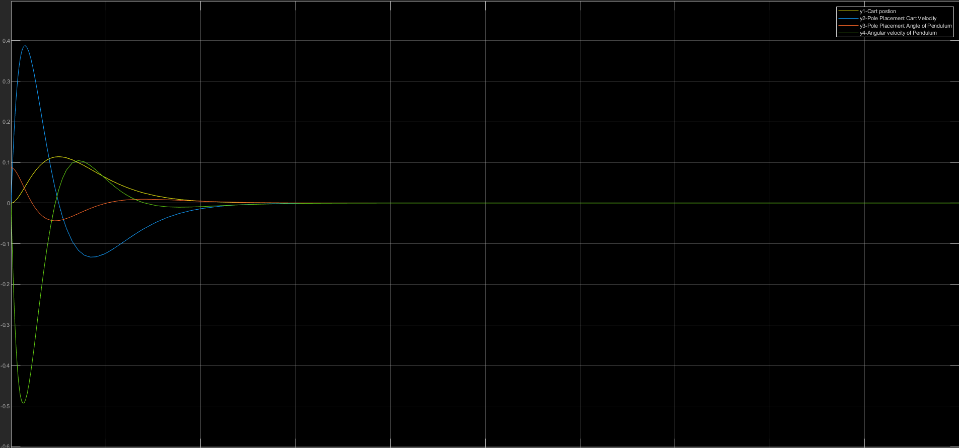
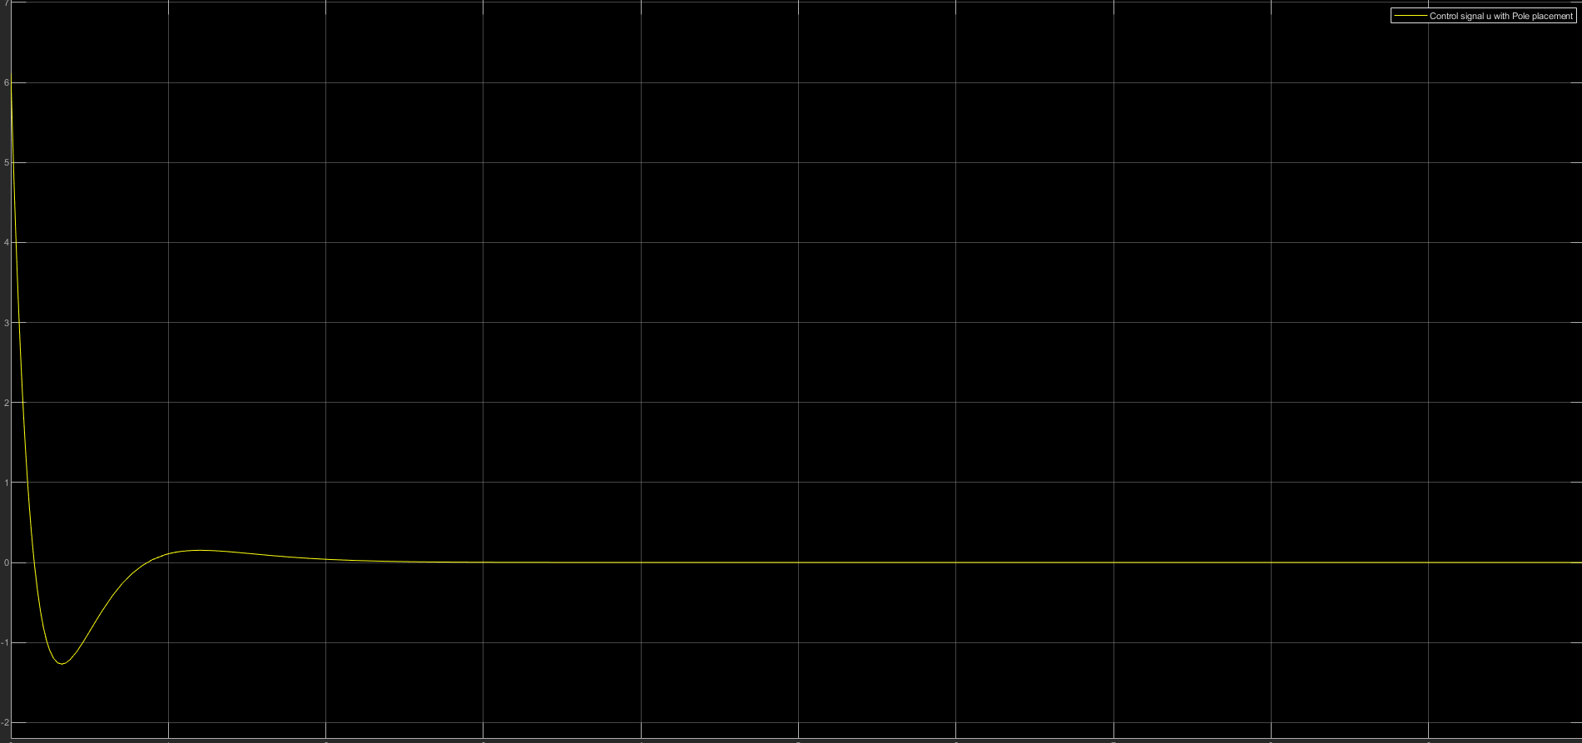

b.
We have the same conditions here. Designing an LQR controller this time.
From the provided error equation, we are trying to minimize the cost of states Cart velocity, Angle of Pendulum and the actuator signal u.
For designing this I have used parameters,
L1=3;(lambda1)
L2=2;(lambda2)
Weight matrix of states
Q=[
1 0 0 0;
0 1 0 0;
0 0 L2 0;
0 0 0 0;
];
Weight matrix of control input
R=L2;

There exists a solution S for the continuous Algebraic Ricatti Differential Equation. This means that an optimal control trajectory exists.

I tried a few random values for L1 and L2.I didn’t further go into tuning the parameters L1 and L2 as I found response to satisfactory and comparable to the pole placement version. With the Q matrix I chose I was able to optimize the cost for the states Cart position, Cart velocity and Angle of pendulum.

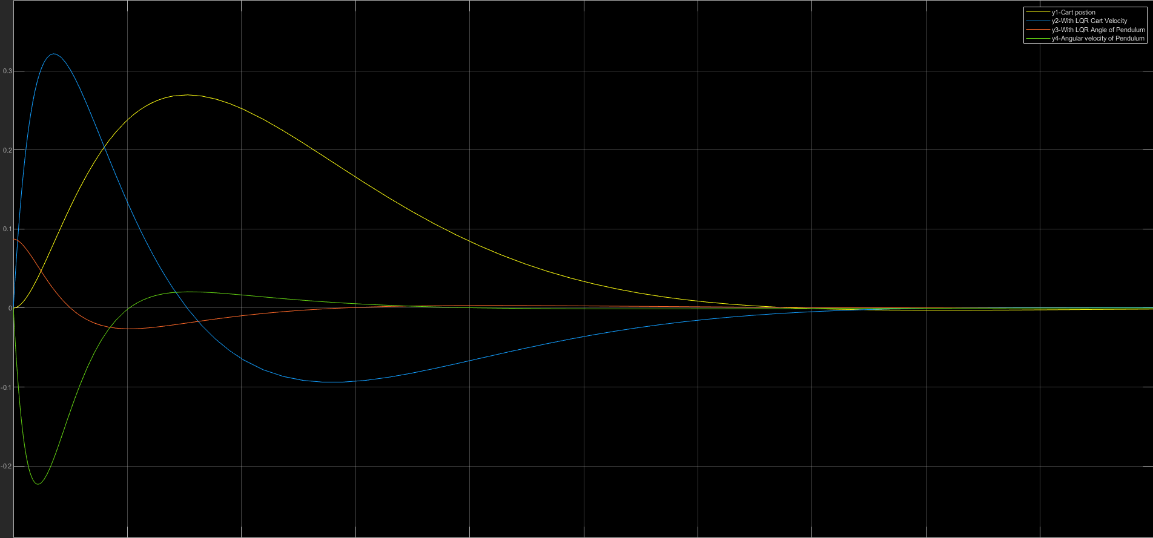
The observations and comparison graphs are provided below. I didn’t calculate the area under the graphs but just looking at the response, it looks like LQR controller performs better in terms of the path taken and cost reduction.
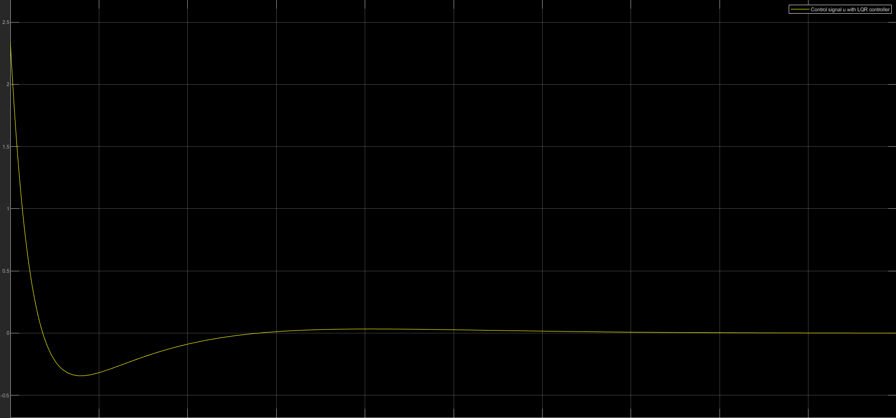

Problem 2:

Given that not all edge cases were covered explicitly in problem statement I had to make a few assumptions by myself.
- Forced stop by the user by pressing the stop button does not cause a complete alarm.
- When the oven has been inactive and the timer resets due to this, there won’t be alarm.
- When the power is set to zero once the cooking started, this will suspend the timer as like a door open case.

The model has two subsystems:
- A chart for the Oven State Control.
- A timer subsystem which is a Matlab function which handles the timer updates.

In the chart, there are two parallel superstates: One is the oven power control which could be OFF,ON or suspended and other is timer control which controls the state of the external timer subsystem.
A modest user interface is made to test this. The alarm is the smiley face lamp which glows for a few seconds on successful cooking.
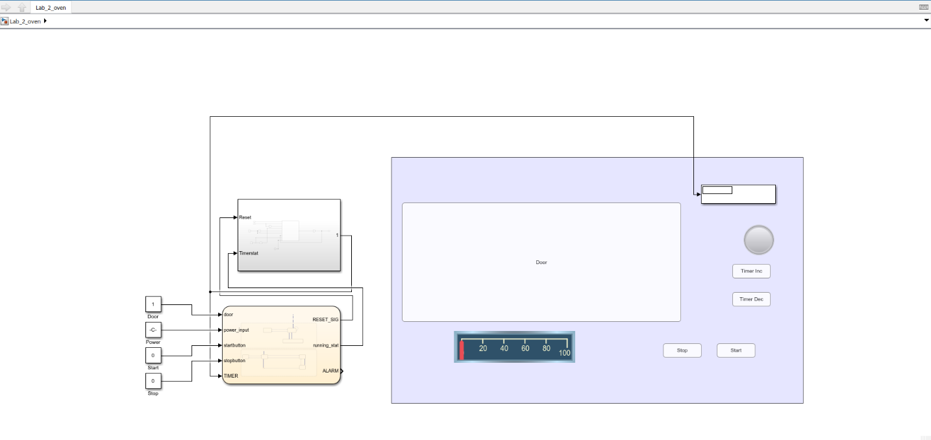

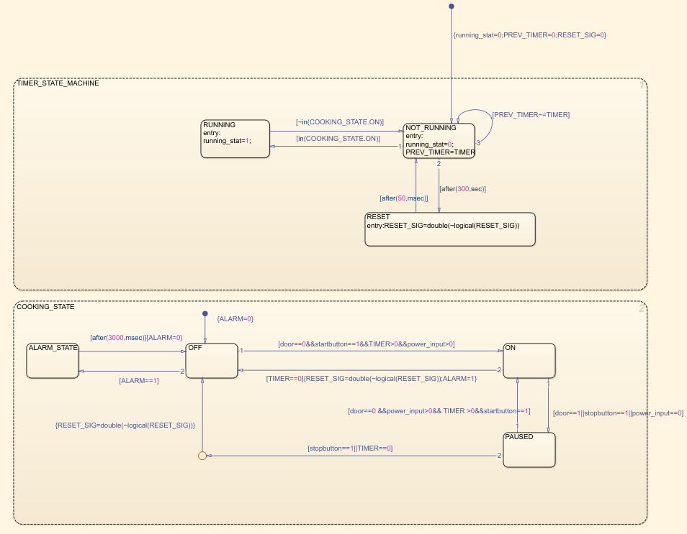

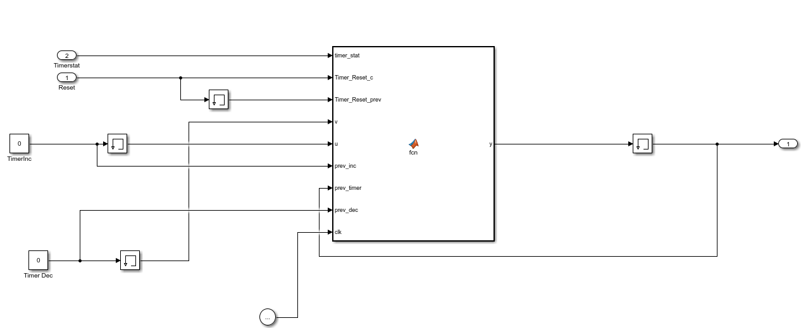

Problem 3:
The Model has two subsystems
- A controller unit which makes all control decisions
- An elevator unit which is just the actuator.
Controller provides a speed data signal to the elevator and elevator in turn provides a position data signal back to the controller.
I designed both of the units as stateflow charts and since they are in loop, the second chart is triggered by a function call from first chart.
The block diagram of the controller is given below as asked in the problem statement, I have tried to somewhat isolate different components from each other. There are four main components in the controller as you can see in the block diagram. Out of the decision manager is where the elevator algorithm is present.
Elevator algorithm
The algorithm used is as follows:
- When the elevator is idle, whichever floor is pressed first becomes the final target floor. The direction is set based on this.
- If there are other floor requests on the way to the target, those requests will be serviced along the way.
I believe this is close enough to a typical elevator behavior.
The decision algorithm feeds on a queue which is updated by the button manager. If at all the a new algorithm needs to brought in, only the decision manager component needs to changed.
The elevator unit chart is a relatively simple and it updates the position of the elevator based on the speed input.
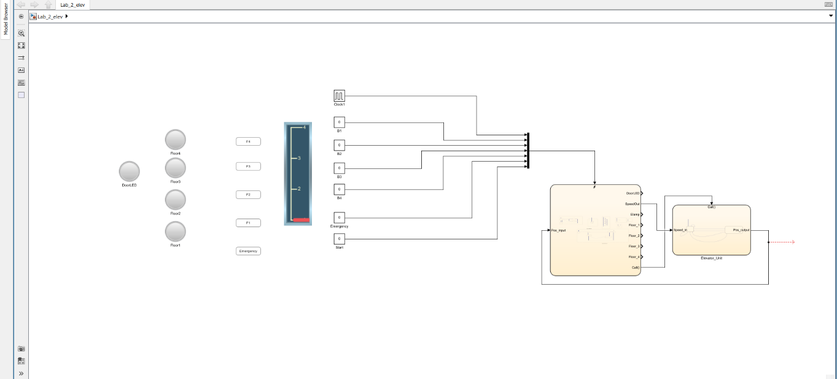
Again as for the second part of the problem a modest animated interface has been made for testing the model.
